**Hydrodams Advocacy**

**Dawa Yangi Sherpa, EPSM ‘20**

A dam is a barrier that stops or restricts the flow of water or underground streams. The world's free-flowing rivers have been destroyed with about 50,000 dams (height of 15 meters or more), and millions of smaller dams that have been built over centuries. While analyzing the process of

dam-building, there are two critical aspects to discern: the importance to recognize the cumulative impacts from multiple dams in a river, and to be critical of the numbers in reports, " *Who are counted as Project Affected People (PAP)?* " Once the dam is physically in place, we can see the direct visible impact from the barrier that alters the course of a free-flowing river. However, the process from site selecon to the compleon of dam-building results in the loss of traditional homelands, forced migration, loss of culture, and destabilization of the local populaon's livelihoods, to name a few. The environmental impacts are immense; ranging from the destruction of riverine ecology, loss of arable land, increase in dam-induced floods, sedimentation, increased risk of glacial lake outbursts (GOLFs), methane emissions from reservoirs further contributing to climate change, along with several environmental violations.

After receiving the Tishman Award for Hydrodams Advocacy Project, I reached out to several organizations working against dam-building in the Hindu Kush Himalaya (HKH) region. The HKH region accounts for 240 million hill and mountain people across the eight countries sharing the region. The HKH region is the headwaters for major rivers in Asia, supporng 1.65 billion people in the river basins downstream . The region is rich in biodiversity and culture, dominated by 1 mountain communities composed of tribal groups, indigenous and ethnic minorities. The geographical terrain of the region is fragile, with a high risk of erosion and landslides, it is also more susceptible to the impacts of climate change.

***Dam-building in South Asia***

In the past few decades, there has been a resurgence of dams in South Asia. Hydrodams are promoted as a "green" energy solution. The pro-dam narrative is also dominated by transnational actors invested in the objects of financialization using the capitalist mode of organizing through global environmental governance. The increasing trend of Environmental Impact Assessment (EIA) approval from the governments in the region is problematic. The construction of dams along the rivers is of poor quality. It lacks adequate assessments of the potential cumulative impacts of the series of dams on the river construction of hydropower dams in the region. It is critical to note that the HKH region accounts for the water resource of 1.65 billion people in the river basins downstream. Any changes to the river systems will impact the sustenance of local populations, fishing communities, and biodiversity in the region from

1 Wester, Philippus, et al. “The Hindu Kush Himalaya Assessment.” *SpringerLink* , Springer, Cham, link.springer.com/book/10.1007/978-3-319-92288-1.

1

activities like forest clearance for dam-building purposes. The governments in the region equate *dam-building with naon-building* . The development of hydroelectric dams has evolved to surpass the global North, global South relations. In the last few decades, Chinese dam builders and financiers have gained foong in the HKH region and gone global, with projects reaching throughout Africa and South America . The growth in China’s domestic dam industry is an effort 2 to boost its economy with incentives for companies to expand their overseas business. Therefore, advocacy against dam-building in the region is an uphill bale.

The degree of social mobilization and democracy mediate the effects on big dam building . Aer 3 the global coronavirus pandemic hit the regions, all the groups and organizations on the ground have lost their ability to mobilize. The challenge was to keep up the momentum on advocacy against hydrodams in mes when the need shied to health and safety. In the midst of the global pandemic, in March 2020, India’s Ministry of Environment And Climate Change put out the new dra Environmental Impact Assessment 2020 which strongly favored industries. Many experts pointed out that the proposed dra EIA 2020 diluted several existing rules and would prove to be disastrous to the environment and public health of the communities. The notification put another set of challenges for the an-dams advocacy groups as the dra EIA had provisions like extension of compliance reports from 6 months to a year, and also proposed to exempt projects from public consultation and participation in comments. Some taccs proposed included digitizing clearance processes to hasten project approval, limiting definitions of what would count as eco-sensitive areas and eliminating or restricting scientific experts in the field from consultation. All of which led the groups and organizations advocating against dam-building to scramble for resources.

After extensive outreach I successfully connected with three organizations or groups in India to collaborate on advocacy materials against dam-building. In my initial communication with the groups in India, I received requests to keep the organization anonymous due to increased surveillance which might jeopardize the safety of the activist groups. Given the circumstances, we agreed to collaborate on projects that would not involve any financial transactions and we came up with projects that would be more effective use of my time. Upon the group's request, I had to adjust my plans to produce a pamphlet because the lockdowns due to coronavirus would make it almost impossible to safely distribute or use pamphlets for advocacy. Therefore this summer, I am working to produce graphics for digital advocacy. In my effort to get a comprehensive set of graphics with an aim to appeal to a broader audience, I am collaborating with local graphic designers to produce initial drafts for social media platforms. After a set of

2 Dharmadhikary, Shripad. “Mountains of Concrete: Dam Building in the Himalayas.” *International Rivers* , International Rivers, Dec. 2008,

www.internationalrivers.org/resources/mountains-of-concrete-dam-building-in-the-himalayas-3582 . 3 Khagram, Sanjeev. Dams and Development: Transnational Struggles for Water and Power. Cornell University Press, 2004. JSTOR, www.jstor.org/stable/10.7591/j.ctv3mtbqn . Accessed 15 Aug. 2020.

2

initial drawings, I shared the graphics with the groups and got feedback to improve and change the approach. These are some of the initial drawings of the digital advocacy. I am also working on developing icons specific to the region to advocate for local populations and local biodiversity being impacted from dam-building. Hydro Dams impact communities and the environment at varying stages of the project. Therefore the advocacy in progress will need a lot more feedback from groups to reach a broad audience and create an effective awareness.

**Graphic #1: Threatened Fish Population**

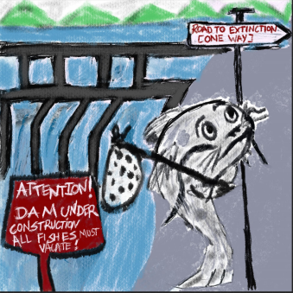

3

**Graphic #2: Impacts of Hydrodams**

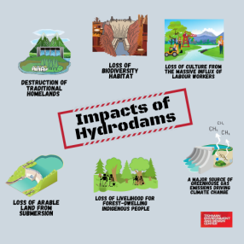

**Graphic #3: Stop Hydropower dams (English and Hindi)**

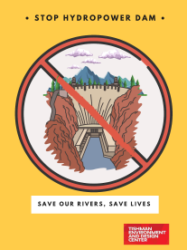 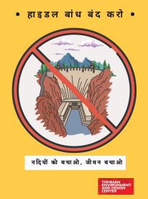4

For another advocacy project, I connected with an organization in India, working on a campaign for free-flowing rivers in the HKH region. This summer, I am collaborating with a researcher activist to put together a report to build a case for a free-flowing river. We are at an initial draft phase and will be finalizing the release early next month. The background material focuses on the river's geographical features, the current status of the region, the demographics, and the increase in hydroelectric power projects in the HKH region. One of the goals is to highlight the geological features of the region, which are at high risk of landslides and floods, and build the case against the economic feasibility of dam-building in the area and stop the degradation of the environment, along with the risk to local indigenous people and the downstream communities. Once the report has been finalized, we aim to start local campaigns, produce a campaign logo for free-flowing rivers, organize community meetings and conferences to create awareness, and publish and print pamphlets in multiple languages. For reference, I've added the draft logo of the campaign. Once it is finalized, we will be using it for reports, conferences, and other materials.

**Graphic #4: Free-Flowing river**

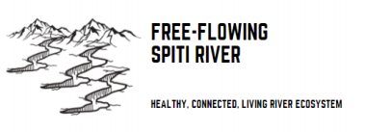

**Update on the Award for Excellence in Climate, Environmental Justice and Sustainability from the Tishman Environment and Design Center**

The project on *Hydrodams advocacy* was part of the course *Global Environmental Politics and Policy* taught by Leonardo Figueroa Helland, Chair of Environmental Policy and Sustainability Management (MS). I would like to thank Leo for his guidance, feedback and resources that helped to produce a body of work to highlight the intersection of injustices from the dynamics of power, privilege, dominance of the global north, and the influence of transnational actors. I would like to thank Sunjam Kaur, EPSM ‘20, for all the feedback she gave throughout the process of the initial designing and creating virtual content for digital advocacy. Many thanks to the local digital amateur friends who agreed to collaborate and give feedback on the initial digital contents for advocacy. Their interpretation of the *hydrodams as an environmental*

5

*injustice issue* allowed me to see digital advocacy in a broad spectrum. I would also like to thank the BIPOC Earth group at the New School, who have immensely helped me navigate frameworks, be critical of the space I hold while framing issues around injustice, and helped me to reflect, learn and grow.

The initial budget for the Hydrodams Advocacy project was for printing and distribution of materials in the local community. After some initial communication, the groups that I am working with felt the need to focus on digital advocacy. On the other hand, they were also very cautious and wanted to avoid financial transactions with an external entity. Therefore, we agreed that for me the project was solely on a volunteer basis. To utilize the award funds, I collaborated with a few local graphic designers and local artists to produce drafts for digital advocacy. I moved the initial printing and distribution budget to compensate for the local artists and designers. I am currently collaborating with the artists to produce drafts for the groups—part of the funds utilized to provide them with subscripons and tools to create the designs. The aim is to produce 10-15 graphics for social media platforms for digital advocacy. Once finalized, the graphics will also be translated into Hindi and other local languages. Some of the funds will be used to cover fees for translations.

As for the free-flowing rivers campaign, it is in the initial stage of planning. The report will be finalized by the end of September. Once it is ready to be published, I plan to circulate it with online platforms. I will be using a poron of the funds for distribung and producing the report along with other advocacy materials once we finalize them in the next few months. I have collaborated with a local arst to create graphics and icons, specific to the area, for digital advocacy and prints. In the next few months, I will also be facilitating community meetings through video calls. We will most likely be using some funds to organize and promote the events digitally.

Additionally, I am also reaching out to groups in Northeast India and Mid-western Nepal to get input and conduct informational interviews to see if there is an interest in collaborating on projects to advocate against dam-building in their region. Given the circumstances of remote working, current global pandemic, and callousness from several grassroots organizations, the plans to connect and be resourceful to organizations is uncertain. For now, the progress with existing organizations and groups seem very promising. The central messaging of the advocacy is clear. *Hydropower dams are not the solution to energy demands in the Hindu-Kush-Himalayan region.*

6